绝密 ★ 考试结束前

全国2013年10月高等教育自学考试

基础英语试题

课程代码：00088
请考生按规定用笔将所有试题的答案涂、写在答题纸上。

选择题部分
注意事项：
1. 答题前，考生务必将自己的考试课程名称、姓名、准考证号用黑色字迹的签字笔或钢笔填写在答题纸规定的位置上。
2. 每小题选出答案后，用2B铅笔把答题纸上对应题目的答案标号涂黑。如需改动，用橡皮擦干净后，再选涂其他答案标号。不能答在试题卷上。

一、词汇应用和语法结构（本大题共30小题，每小题1分，共30分）
（一）词汇应用（15分）
选择最佳答案完成句子，请将其代码填涂在“答题纸”相应的位置上。错涂、多涂或未涂均无分。
1. In the past, ______ goods were made to last for ever.
A. industry B. industrial
C. industrially D. industrialized
2. Foods composed of two or more ingredients must ______ labels listing all ingredients in the order of predominance.
A. stick B. hold
C. produce D. bear
3. I would like to try that coat on, but I don’t know if it is my ______.
A. shape B. pattern
C. model D. size
4. The manager thought very ______ of my son.
A. highly B. better
C. well D. high
5. Many people ______ suicide in times of inflation.
A. went B. did
C. committed D. performed
6. Only very rich people can ______ this very expensive house.
A. afford B. supply
C. give D. take
7. You’ve been overworking recently, and would find a holiday ______.
A. meaningless B. beneficial
C. profitable D. energetic
8. The most obvious purpose of advertising is to ______ the consumer of available products or services.
A. tell B. give
C. provide D. inform
9. Because of advertisement, consumers think that they want ______ that they do not need.
A. anything B. something
C. nothing D. everything
10. In a time of social reform, people’s state of mind tends to keep ______ with the rapid changes of society.
A. step B. progress
C. pace D. touch
11. Convenient foods which are already prepared for cooking are ______ in grocery stores.
A. ready B. approachable
C. possible D. available
12. These goods are essentially for ______, though a few of them may be sold on the home market.
A. export B. import
C. sales D. commerce
13. The price of beer ______ from 50 cents to 4 dollars per liter during the summer season.
A. ranged B. differed
C. altered D. separated
14. You can take as many as you like since they are free of ______.
A. payment B. money
C. charge D. cost
15. If you allow us a 3% ______ on the price, you will give us the added incentive to sell your products.
A. deduction B. discount
C. lower D. drop
（二）语法结构（15分）
选择最佳答案完成句子，请将其代码填涂在“答题纸”相应的位置上。错涂、多涂或未涂均无分。
16. Every word on a label is important in protecting you ______ buying an inferior product.
A. from B. of
C. off D. against
17. These things earn money even though no actual goods ______.
A. are changed hands B. change hands
C. change hand D. is changed a hand
18. Britain was ______ in the world with 56 million people on 0.18% of the world’s land.
A. the fifth most densely populated B. the most densely fifth populated
C. the fifth densely most populated D. the most densely populated fifth
19. It was about 7∶45 ______ a Thursday morning in October.
A. at B. in
C. on D. by
20. Mr. Becker enjoyed ______ outdoors in the bright sunshine.
A. being B. be
C. been D. was
21. We are going to visit ______ tonight.
A. the Green B. Greens
C. Green D. the Greens
22. A reception ______ in honor of the guests tomorrow morning.
A. will hold B. holds
C. is held D. will be held
23. Martin’s garage, ______ the car had been taken, was not far away.
A. which B. to which
C. to where D. in which
24. I wonder how much ______ the shoes.
A. you pay for B. you paid for
C. you paid D. did you pay for
25. The bus came after I ______ for about half an hour.
A. was waiting B. waited
C. wait D. had been waiting
26. She speaks to me ______ she were my mother.
A. even if B. although
C. as if D. if
27. I wish that I ______ the meeting last Wednesday.
A. could attend B. could have attended
C. have attended D. attended
28. As ______ announced in today’s papers, the Shanghai Export Commodities Fair is also open on Sunday.
A. being B. is
C. to be D. been
29. The medicine is on sale everywhere. You can get it at ______ chemist’s.
A. each B. some
C. certain D. any
30. The organization had broken no rules, but ______ had it acted responsibly.
A. neither B. so
C. either D. both
二、改错 （本大题共10小题，每小题1分，共10分）
下面句子中有 A、B、C、D四个划底线部分，其中有一个是错误的，请将其代码填涂在“答题纸”相应的位置上，无需改正错误。

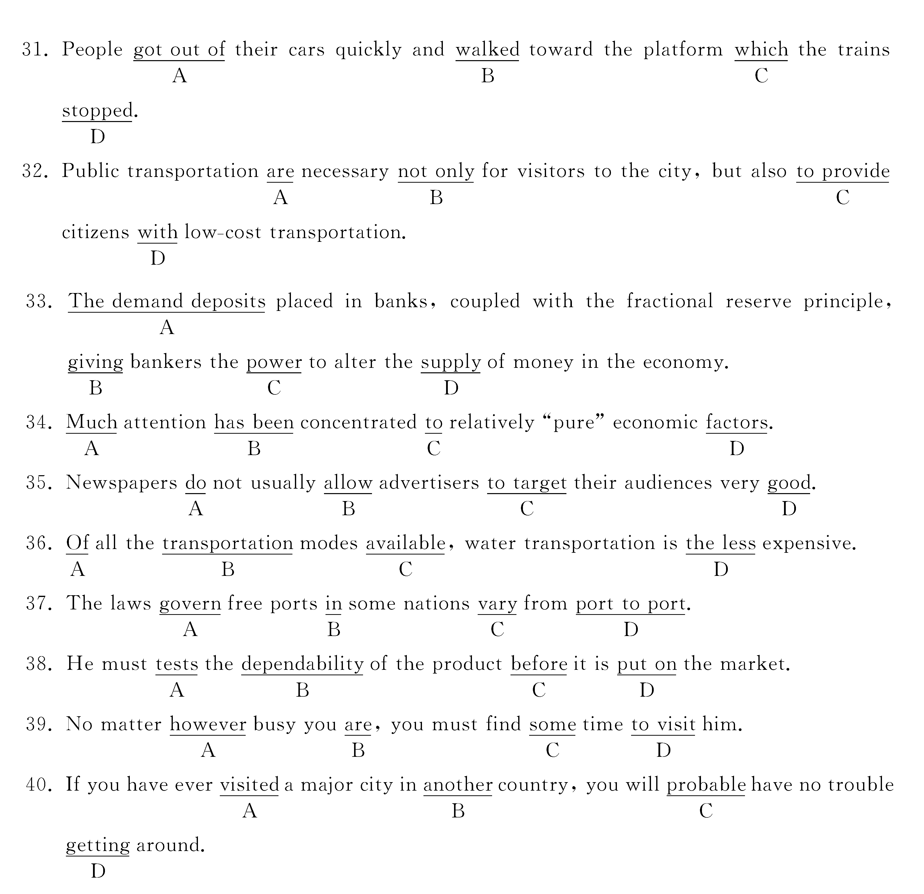
三、完形填空（本大题共15小题，每小题1分，共15分）
选择最佳答案完成句子，请将其代码填涂在“答题纸”相应的位置上。错涂、多涂或未涂均无分。
The introduction of new ___41___ of rice and wheat in Asia and Latin America ___42___ known as the “Green Revolution”. So far the new seeds and the ___43___ technology have not resulted ___44___ increased agricultural ___45___ per head or reduced malnutrition. The direct, quantitative ___46___ of introducing food grains have been modest.
The indirect and quantitative effects, ___47___, have sometimes been significant. The new technology has ___48___ changes in crop pattern and in ___49___ of production. It has ___50___ the development of a market ___51___ capitalist agriculture. It has encouraged the ___52___ of wage labor, and thereby helps to create a class of agricultural laborers. It has increased the ___53___ of landowners, and this in turn has been ___54___ with a greater polarization of classes and ___55___ conflict.
41. A. technology B. methods
C.varieties D. way
42. A. been B. has been
C. has D. have been
43. A. accompanying B. together with
C. along with D. with
44. A. from B. by
C. out of D. in
45. A. activity B. production
C. revolution D. seeds
46. A. affect B. affects
C. cause D. effects
47. A. thus B. however
C. moreover D. also
48. A. led to B. result in
C. took place D. bring about
49. A. forms B. patterns
C. methods D. styles
50. A. hurried B. yielded
C. slowed D. accelerated
51. A. lead B. oriented
C. guide D. produced
52. A. development B. presence
C. growth D. show
53. A. possibility B. power
C. classification D. market
54. A. associated B. conformed
C. suited D. apply
55. A. comforted B. concealed
C. exposed D. intensified
四、阅读理解（本大题共10小题，每小题2分，共20分）
本部分有两篇短文，每篇短文后有五个问题,每个问题有四个供选择的答案，选择一个最佳答案，将其代码填涂在“答题纸”相应的位置上。错涂、多涂或未涂均无分。
Passage 1
Today television is one of the most popular forms of entertainment in the home. Some people in places where television reception is good may think that television has taken the place of radio. Television, however, is actually a kind of radio. It uses special equipment for sending and receiving the picture. The television sound system uses the same type of equipment that is used in other forms of radio.
Exchanging messages with ships at sea was one of the first uses of radio. Modern radio is still used for this purpose and for communication across oceans. On land too radio provides a means of instant communication even with moving vehicles such as taxicabs or service trucks.
Police forces use two-way radio to get information to and from officers in squad cars and on motorcycles. Small portable sets make it possible to communicate with a central exchange while walking or riding in a city or over a countryside. Observers in airplanes can report traffic accidents and traffic jams by radio to police officers on the ground.
Radiotelephones are used in many places. Connection with the regular telephone service can be provided for boats, trains, and cars. Isolated places in deserts, forests, and mountainous regions are linked by radiotelephone in many parts of the world. Thus by means of radio people can communicate with others wherever service is provided.
56. According to the passage, television ______.
A. has taken the place of radio B. is no longer popular in the home
C. can be regarded as a kind of radio D. has nothing in common with radio
57. In Paragraph Two, “this purpose” refers to ______.
A. exchanging messages with ships at sea
B. communication across oceans
C. sending and receiving the picture
D. instant communication with moving vehicles
58. Modern radio is used in many ways. Which of the following is NOT mentioned in the passage?
A. At sea. B. On land.
C. In the air. D. Underground.
59. The word “isolated” in the last paragraph means ______.
A. sandy and mountainous
B. clean and not polluted
C. without any living things
D. separated or distant
60. The best title for the passage is ______.
A. Television and Radio
B. Radio and Its Use
C. Radio and Radiotelephones
D. Modern Communication
Passage 2
The use of the motor car is becoming more and more widespread in the twentieth century; as an increasing number of countries develop both technically and economically, a larger proportion of the world’ s population is able to buy and use a car. Possessing a car gives a much greater degree of mobility, enabling the driver to move around freely. The owner of a car is no longer forced to rely on public transport and is, therefore, not compelled to work locally. He can choose from different jobs and probably change his work more frequently as he is not restricted to a choice within a small radius. Traveling to work by car is also more comfortable than having to use public transport; the driver can adjust the heating in winter and the air conditioning in summer to suit his own needs and preference. There is no irritation caused by waiting for trains, buses or underground trains, standing in long patient queues, or sitting on windy platforms, for as long as half an hour sometimes. With the building of good, fast motorways long distances can be covered rapidly and pleasantly. For the first time in this century also, many people are now able to enjoy their leisure time to the full by making trips to the country or seaside at the weekends, instead of being confined to their immediate neighborhood. This feeling of independence, and the freedom to go where you please, is perhaps the greatest advantage of the car.
When considering the drawbacks, perhaps pollution is of prime importance. As more and more cars are produced and used, the emission from their exhaustpipes contains an ever larger volume of poisonous gas. Some of the contents of this gas, such as lead, not only pollute the atmosphere but cause actual harm to the health of people. It is also becoming increasingly difficult to deal with the problem of traffic in towns; most of the important cities of the world suffer from traffic congestion. In fact, any advantage gained in comfort is often cancelled out in city driving by the frustration caused by traffic jams. The mounting cost of petrol and the increased license fees and road tax all add to the driver’s worries. In fact, he must sometimes wonder if the motor car is such a blessing (幸事) and not just a menace (令人讨厌的事).
61. More and more people can afford to buy and use cars because ______.
A. an increasing number of cars are being produced
B. the cost of cars is getting cheaper with the development of the technology
C. lots of countries have become more developed
D. the use of cars has proved to be more economical
62. The word “radius” in the first paragraph means ______.
A. country B. circular area
C. routine D. period of time
63. The author believes that the motor car is ______.
A. rather a menace than a blessing
B. rather a blessing than a menace
C. a blessings as well as a menace
D. a blessing
64. The advantages of having a car are best experienced in the driver’s ______.
A. freedom in choosing his job
B. comfort during the travels
C. enjoyment of his leisure time
D. feeling of independence
65. What is considered by the writer as the greatest menace to the people caused by the widespread use of motor cars?
A. Air pollution. B. Traffic jams.
C. Fatal diseases. D. High cost.

非选择题部分
注意事项：
用黑色字迹的签字笔或钢笔将答案写在答题纸上，不能答在试题卷上。

五、单词或短语的英汉互译（本大题共10小题，每小题1分，共10分）
(一) 将下列词语译成中文 （5分）
66. visible trade
67. mass-production methods
68. inflation
69. zebra stripes
70. aggregate output
（二）将下列词语译成英文 （5分）
71. 医疗设备
72. 原材料
73. 必修课
74. 消费者需求
75. 经济增长
六、 英汉句子互译 (本大题共4小题，共15分）
（一）将下列句子译成中文
76. From the 1950s to the 1970s, Japan developed much more rapidly than at any other time in her history. (4分)
77. Many nations have ports where ships from other countries can unload goods for trade. (4分)
（二）将下列句子译成英文
78. 英国的工业生产曾长期在世界上占领先地位。 (4分)
79. 没有交通运输，现代生活就无法存在。 (3分)

